The Spindle. APRIL 2021. cycleclubsudbury.com

Well, we’ve made it this far and I hope everyone has made it through safely!
Perhaps if everyone behaves and follows the rules, we can hopefully have a full summer of biking events and riding. The committee have been very busy getting our normal cycling schedule back on track by detailing exactly what is required from us to take part in these events in the coming months. What follows further on are the rules (not recommendations!) that we must all abide by to make sure we can enjoy taking part in them. For goodness sake, please read and digest them carefully as Joe Public like nothing better than moaning about any misdeeds they spot by cyclists (usually via social media) and highlighting any of us who transgress!
Our chairman James issued a press release recently (shown below) which summed up our current situation quite succinctly....... Rog

With the easing of restrictions from the 29th March, Cycle Club Sudbury is able to re-introduce their Sunday clubs runs from Market Hill in the town centre.
The government guidelines and British Cycling giving the go ahead for groups of 15 cyclists being able to ride together, is a massive boost for all cycling clubs and cyclists, who have had to be content with minimal company whilst cycling for the past 12 months.
Currently, Market Hill in Sudbury, offers a large pedestrianised area which will allow for cyclists to meet and allow for plenty of social distancing allowing compliance to the current rules.
Exciting times ahead and let’s hope that this is the start of the road back to normality.
James Newton CCS Chairman

GOOD NEWS AT LAST!! Collated by Robin Weaver, James Newton & Martin North.

The following events will for the time being, at least, be organised and run very differently, with Covid restrictions in place.
Please make sure you read the following notes for details of:-
Club Rides – Evening Time Trials – Audax Rides

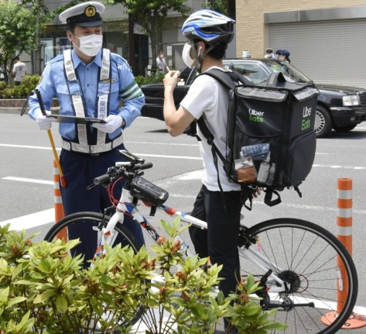
Sunday Rides/Club Group Rides
British Cycling have agreed with Sport England that BC-affiliated clubs can recommence club organised group rides of up to 15 riders, from 29 March.
Previously there were 3 groups meeting on Sunday mornings.
- Slower Group- Riders at a rate of 10-14mph on a variety of bikes, always stopping at a Café. Social ride in which no-one gets left behind. 25-45miles long
- Medium Group- Riders at a rate 14-18mph usually on race bikes, sometimes stopping at a Café. Social ride in which no one gets left behind. 25-55miles long
- Fast Group- Riders at a rate 18mph+ always on race bikes, sometimes stopping at a Café. Usually aggressively ridden with riders sometimes left when close to rides completion. 55miles+.
- As, we are sure, everyone is aware we are in a privileged position, as a British Cycling Affiliated Club, to be able to organise group rides with up to 15 riders riding collectively as of the 29th March.
- Great news!!! Yes indeed, but to avoid confusion, poor perception by the public and to give comfort to those who are still, understandably nervous, we need to try and put some form of guidelines in place.
- So with that in mind please see below:-
- As generally people will be allowed to meet in “bubbles” of 6, it is suggested that people gather in groups of 6 prior to setting off.
- Therefore it is suggested that the slower group meet at St Peters Church, Market Hill, as per the previous norm, with the medium group meeting opposite the Black Boy Pub also Market Hill, whilst the faster group meet at the bottom of Market Hill opposite Greggs.
- When meeting in these groups please try to group in collectives of 6no.
- When meeting it is an absolute necessity that face coverings are worn. Buffs or masks are adequate but please do not turn up without one. If it’s good enough for Mathieu Van Der Poel it’s good enough for us!!!!!
- When setting off, we will be able to leave in groups of 15, it is assumed that we will be able to organise ourselves so we don’t have 15 people riding together and leaving 1 other to ride solo!!
- In order to ensure overtaking and bunching up of groups is avoided we will need to leave at staggered times with the Faster group leaving at 9am prompt, the Medium group leaving at 9.05am and finally the slower group leaving at 9.10am.
- Though, due to the fact that people are outside and face to face interaction is minimal, it is suggested that riders try to maintain 1m distance when riding. Riding “crocodile” fashion automatically gives a metres gap but riding 2 abreast will require a bit more concentration and vigilance.
- Not that we believe anyone would, please do not share food or drink and when stopping at Cafes please organise yourselves into groups of 6.
- Also please try to avoid physical contact (no hugging and kissing people!!).
- The Public perception is key to ensure that these rides continue so please try to stick to these guidelines as best as possible at all times.
- Further to the above we look forward to restarting rides in company once again and hope that we can continue them for the foreseeable future.
*As a supplement to that it would be appreciated if you would include the following request for ride leaders. Many thanks....Martin North

Hopefully the encouraging news about Sunday Club Runs restarting on Easter Sunday 4th April will have reached you already. Following on the well regarded practice of having a leader for the rides there is a need for volunteers to do that for the coming months. Particularly we are looking for leaders for the medium pace group. Please contact MartinNorth at msnorth@waitrose.com or 01787370558 if you are willing to occasionally lead a ride. We need someone to have the honour of leading the first ride of the season on 4 April. As has been the usual practice it's your choice of venue and route.
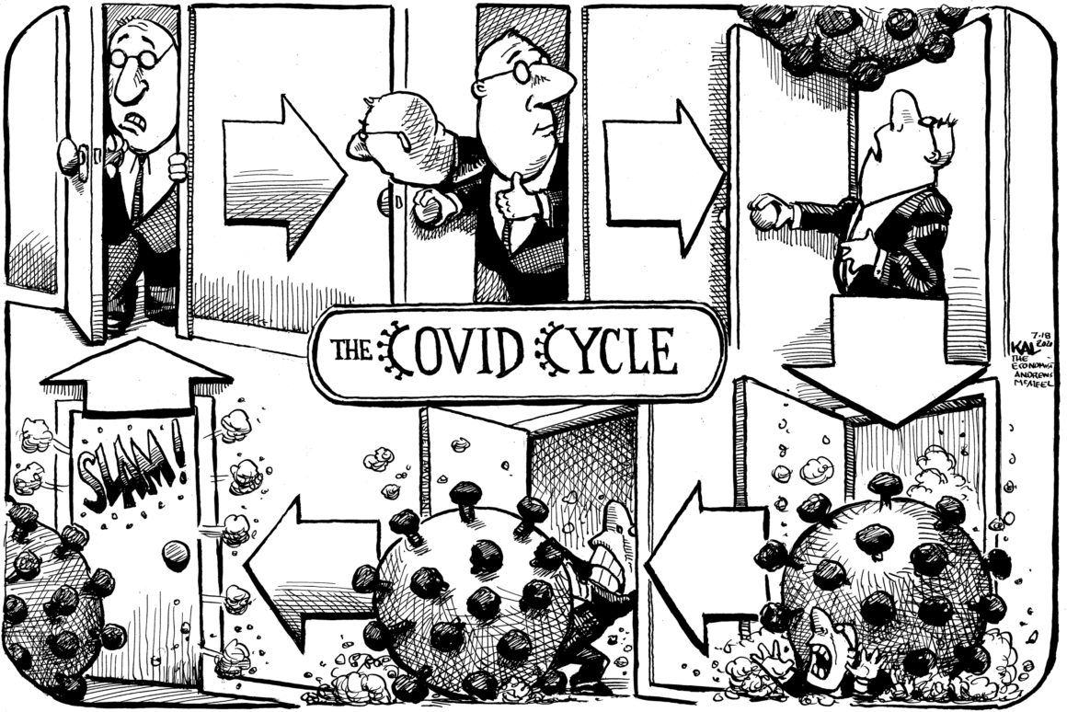
Martin

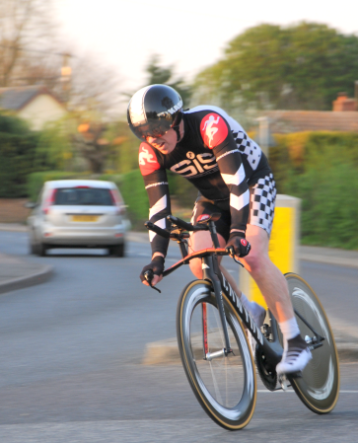
HOW THURSDAY EVENING TIME TRIALS
WILL OPERATE IN 2021..................

Cycling Time Trials have confirmed that both Open (Type A) and club (Type B) time trials can also commence from 29 March. CCS intends to start the Thursday evening time trial series on 6 May.
Post Covid lockdown, these will also be very differently organised, for club first and second claim members only this season - no visitors, unfortunately.
If you're intending to ride, please make sure you read and act on the attached document; 2021TTProcedures.
AudaxUK have also authorised audax rides; CCS audax rides on 10 April and 17 July will now go ahead (10 April rides already 'sold out').
CCS Committee

TIME TRIALS THIS YEAR WILL BE VERY DIFFERENT; APART FROM ANYTHING ELSE, THERE SHOULD BE NO SOCIALISING BEFORE OR AFTER THE EVENT. HOPEFULLY THINGS MAY CHANGE BEFORE THE END OF THE SEASON.
PLEASE READ THE FOLLOWING CAREFULLY..........................................................................

1. As Covid-19 restrictions (social distancing, cleansing etc) will still apply the number of events will be reduced from 20 to 16 or 17. This will allow time for clearing up/sanitising etc after events before it gets dark.
TTs on 16, 23, & 30 April will not be run and the status of the 27 August TT will be confirmed later.
The course for 1st event of the season on 6 May will be changed from Hitcham Hilly to
Lavenham 10.
The interclub events with Colchester Rovers and West Suffolk Wheelers will not take place this year, but club TTs will still be run on those dates..

2. If riders/timekeepers/marshals need to shield, or have any Covid-19 symptoms, however mild, or have received a positive Coronavirus (Covid-19) test result, or live with others who have, they must not attend, until they are recovered or until the end of a 10 day self-isolation period.

3. Riders in events will be limited to 1st and 2nd claim members only, no visitors. There will be a limit of 30 on the number of riders, on a first come-first served basis. This will reduce numbers of riders attending and possible interaction, and enable us to maintain better control, and better communicate with riders if things change.

4. Payment will be £4 a ride for 1st and 2nd claim riders. Payment can be made for the season, at £60; given that weekly prepayment is otherwise required, see 6 below, this might make life easier. In a change of plan, CTT have decided not to increase the ‘per rider’ levy after all this year.

5. Potential riders must notify CCS by email to pamandrobinw@gmail.com before 7pm on the Tuesday evening before an event if they wish to ride. This will enable a start sheet to be pre-prepared and published on the CCS website and Facebook. Riders turning up on the night will not be allowed to ride.

6. Payment. No payment on the night. Payment must be made before 7pm on the Tuesday evening before an event.

Two payment methods;
If you have a PayPal account, you can pay £4 to the email address davem@cycleclubsudbury.com; on the Payment page, add a note of your surname, and TT.
Alternatively, make a payment of £4 by EFT bank transfer to CCS, details; Barclays Bank; Account name Cycle Club Sudbury; Sort code 20 83 50 Account number 30308188. Please use your surname and TT as a payment reference.

7. Riders should time their arrival to suit their start time. Those arriving by car should use the rear of the car park or the spaces outside the village hall, and park in alternate spaces, or nose to nose. Riders must maintain social distancing on arrival, sign on, and then leave the car park for a warm up ride. Warming up using turbo’s in the car park will not be allowed. There should be no socialising in the car park.

8. Riders are to queue individually, respecting the socially distancing markers, to sign on. They must bring their own pen, and collect their number, which will be laid out. Riders are to bring their own pins, or retain for following weeks the pins they use the first time they sign on. Hand sanitiser will be provided.

9. Riders should arrive at the TT start no more than 5 minutes before their start time, to reduce queuing; i.e. no more than 5 riders at the start at any one time. They should queue respecting the socially distancing markers.

10. There will be no pusher-off.

11. The start time keeper will be socially distanced from the start line. Riders must not approach him, or leave anything at the start. Spectators will not be allowed at the start.

12. During the event, overtaking riders are to keep well clear of the other rider, for covid reasons.

13. Riders must not stop at the finish; timekeepers will maintain social distancing. Spectators will not be allowed at the finish.

14. After the event, on returning to the car park riders must return their number by placing in a bucket of antiseptic solution. Numbers will be stored in the bucket until shortly before the next event.

15. Riders should leave the car park immediately after returning their number, without socialising. Results will be posted on the CCS website and Facebook ASAP.

16. Other things to remember; working front and rear lights required,
no U-turns on the course at the start – walk across the road
no warming up on the course after the TT has begun!

17. Marshals. All riders will be required to marshal twice in the season. Please email Robin at pamandrobinw@gmail.com before the start of the season with four dates on which you could potentially marshal, and two will be allocated to you. Marshals must provide their own hi-viz jacket/bib.
18. Signs will pre-sorted into packs suitable for each course, rather than signs being sorted at the start. One marshal (except Hitcham Hilly, two) should place and re-collect all the signs for the course – a car will be needed. Marshals should not share a car. Disposable nitrile gloves will be provided for marshals placing signs, with a bin for disposal of used gloves at the car park. After the TT, signs will be sprayed with antiseptic aerosol.

19. The start timekeeper will place start signs, and store/handle them for the season.

20. The finish timekeeper will place finish signs, and store/handle them for the season.

21. Timekeepers will be issued with watches at the start of the season, and keep the same watches for the season.

Thursday Evening Time Trial Series

Date Course Distance Start Time

May 6 Lavenham 10 13m 19.00
May 13 Brent Eleigh 8.2m 19.00
May 20 Lavenham 10m 19.00
May 27 Lavenham 10m 19.00
June 3 Acton 8.3m 19.30
June 10 Hitcham Hilly 13m 19.30
June 17 Lavenham 10m 19.30 (Note Revised start time)
June 24 Lavenham 10m 19.30
July 1 Brent Eleigh 8.2m 19.30
July 8 Acton 8.3m 19.30
July 15 Hitcham Hilly 13m 19.30
July 22 Lavenham 10m 19.30 (Club 10 Championships)
July 29 Brent Eleigh 8.2m 19.30
Aug 5 Hitcham Hilly 13m 19.00
Aug 12 Acton 8.3m 19.00
Aug 19 Lavenham 10m 18.45 (Jonathan Weatherley
Memorial TT 10m)
The following TT will not take place IF Covid restrictions still apply)
Aug 26 Brent Eleigh 8.2m 18.45

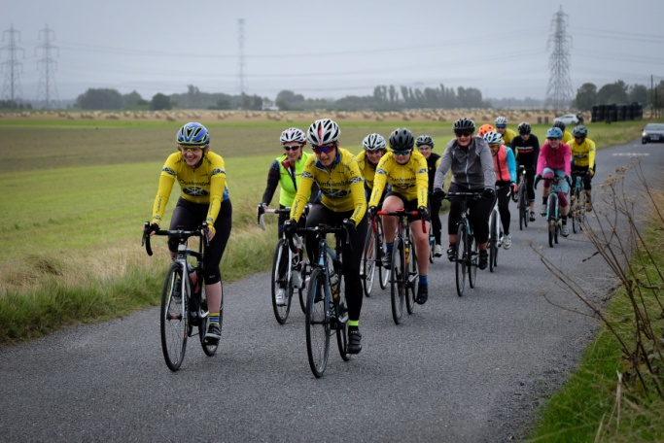
CCS Audax Rides News

News from Ian Lovelock of CCS: - Audax rides from Long Melford, 10 April.
England is currently in lock down, but from end of March we are expecting to be able to meet in groups of up to 6 people and we will be able to take part in formally organized events.
AudaxUK are permitting organised rides to progress as long as we adhere to guidelines. This good news....it allows me to open up a slightly different set of Tour De Stour rides on Saturday 10 April . The event will be stripped down to bare bone and 2 rides of up to 30 people, dispatched in groups of six, will start from Melford Green, Long Melford (opposite Melford Hall). If you want to ride either 100k or 200k along the Stour Valley then please enter as swiftly as you are able via the AudaxUK website at the following links; open to all, not just AudaxUK members:
Grand Tour de Stour 200k - https://audax.uk/event-details?eventId=8903
Tour de Stour 100k - https://audax.uk/event-details?eventId=9065
(Entries for this one (100km) is already full – but there is still space on the 200km ride!!)
(Latest News – 200km ride also now full !)
Contact - ian.lovelock@btinternet.com

Also advance news of CCS audax rides from Bildeston, Saturday 17 July.
As things stand at present, these rides will also be limited to 30 people at each distance, again dispatched in groups of six, from Bildeston Sports field, again with very limited facilities compared to previous years.
These rides are now available to all on the AudaxUK website, so places are being taken already. Open to all, not just AudaxUK members. Enter now if you want to be sure of a ride!
There are 4 rides available;
52k Jane's Lanes audax - https://audax.uk/event-details?eventId=8849
103k Bildeston Lanes audax - https://audax.uk/event-details?eventId=8848
168k 100 Miles of Suffolk Lanes audax - https://audax.uk/event-details?eventId=8847
209k Suffolk Lanes Extravaganza audax - https://audax.uk/event-details?eventId=8846
(Places are already being snapped up for these Audaxes)
If you have any queries, please contact Ian at ian.lovelock@btinternet.com about Long Melford rides, and Robin at pamandrobinw@gmail.com about Bildeston rides

News from Brian Webber
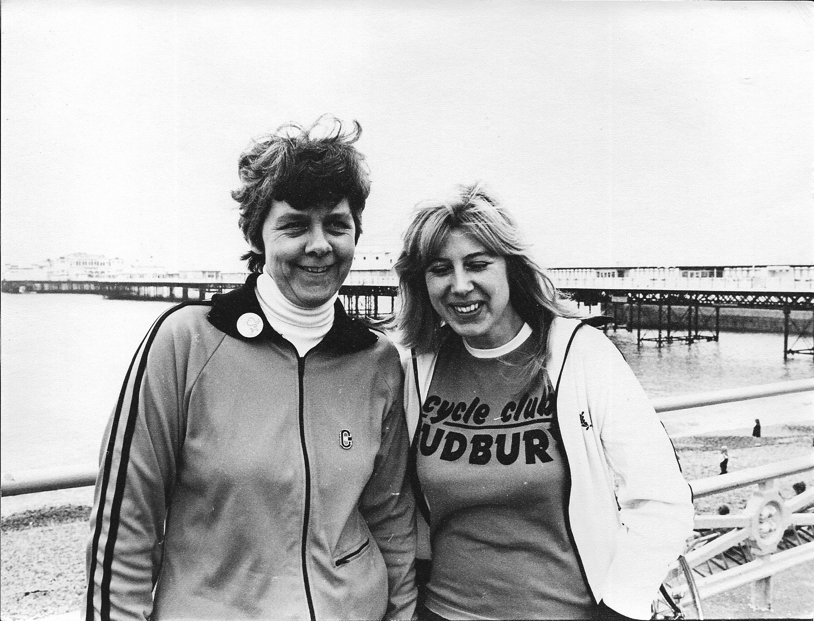
The second week of February this year I was told that two founder members of CCS had passed away last year, they were Marlene and Peter Broomfield this means that out of the nine founder members of CCS Harold is our only survivor.
Marlene was the clubs secretary for a number of years and helped organise and took part in a number of social events. Peter was the clubs treasurer for a number of years and rode in road races as well as riding Time trials. The photo is the clubs first dinner and awards night it was a sausage and mash do at the Boat House in Sudbury.
The mayor Howard Singh had just presented Peter with the Championship shield and was just presenting Andrew Webber with the Clubman of the year award.
The other photo is Marlene with Pat Webber on the promenade at Brighton, after completing the1981 London to Brighton Ride.

Best Wishes in Cycling to everyone stay safe keep well..... Brian W
CCS SPOCO 2021 POINTS SERIES
EAST QUALIFYING EVENTS
(Compiled by David Fenn)
DATE | EVENT | COURSE | DISTANCE & GROUP | SPOCO AREA
3rd April | Kings Lynn CC | B25/33 | 25 - B | East
17th April | Stowmarket & District | BS33 | 20-B | East
18th April | CC Breckland | B10/19 | 10 - A | East
24th April | Kings Lynn CC | B10/37R | 10 - A | East
1st May | Orwell Velo | BS33 | 20 - B | East
3rd May | VC Baracchi | B10/43 | 10 - A | East
8th May | Plomsgate CC | B25/2r | 25-B | East
23rd May | Great Yarmouth | BS13a | 25 - B | East
6th June | Ely & District CC | B10/1R | 10 - A | East
12th June | Godric CC | B10/43 | 10-A | East
3rd July | Norwich ABC | B10/43 | 10 - A | East
4th July | Wolsey RC | B25/50 | 25 - B | East
18th July | Godric CC | B50/19 | 50 - B | East
7th August | Kings Lynn CC | B25/33 | 25 - B | East
15th Aug | Diss & District CC | B25/17 | 25-B | East
22nd Aug | VC Baracchi | B50/17 | 50 - B | East
11th Sept | Norwich ABC | B10/43 | 10- A | East
18th Sept | DAP CC | B10/43 | 10 - A | East
25th Sept | Kings Lynn CC | B10/37R | 10 - A | East
26th Sept | Godric CC | B25/50 | 25 - B | East
2nd Oct | Norwich ABC | B10/43 | 10 - A | East
3rd Oct | Norwich ABC | B25/50 | 25 - B | East

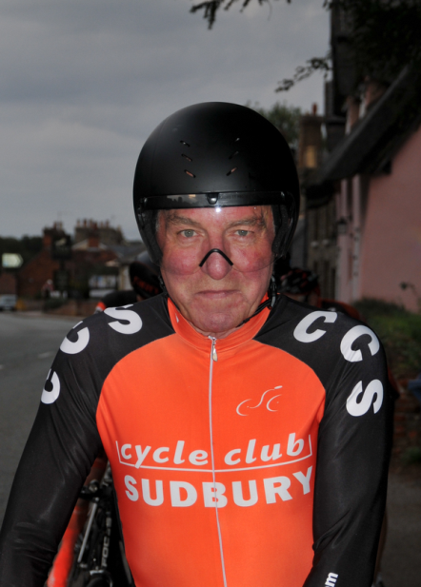
Challenges of Lockdown
By David Fenn

With restrictions placed on the country during lockdown it has been interesting to see how Cyclists have innovated in order to stay fit.
From riding the Turbo, taking part in Zwift racing or getting out on the road!
Outdoor riding was restricted to staying local, whatever that means, individual interpretation of the rules causing much discussion and annoyance to those of us trying to do the right thing.
Personally, I chose to stay within a 10 mile radius of home, but like most cyclists I needed a challenge to maintain my physical fitness and mental health so I signed up for the Cycling Weekly CW5000 challenge.
CW 5000 involves riding 5000 miles in a calendar year either on a Turbo, on the road or a mixture of both. I just can’t imagine how painful riding 5000 miles on a turbo must be so I determined to ride all my miles on the road. In addition to riding the distance Cycling Weekly also set two challenges per month to be completed within the Government Lockdown rules.
The two challenges for January involved completing a two hour ride and riding a road never ridden before. The road not ridden before was an issue bearing in mind the stay local rule and the fact I have ridden just about all the local roads, however I did eventually complete the challenge on a short back road in Borley.
My mileage for January, 716 miles.
The February challenges set by CW were to ride 100 miles in a week and complete a ride with 2500 feet of climbing. The 100 miles in a week was the easy bit, however the 2500 feet of climbing in one ride in what is essentially a flat area of the country and remain local was going to be the real challenge (glad I don’t live in Norfolk).
I determined the ride would need to be based around Stanstead / Glemsford / Hartest in order to include the maximum number of hills in the shortest distance. Following a discussion with club mate Colin Harris we decided to meet in Long Melford the following day. During this discussion Colin mentioned his current spate of punctures due to all the rain washing debris onto the roads. I suggested Colin change his tyres for Marathon Plus as being the best choice of tyre for winter riding, to reinforce my opinion I said I had ridden all winter on Marathon plus tyres without a puncture, I would later regret this endorsement.
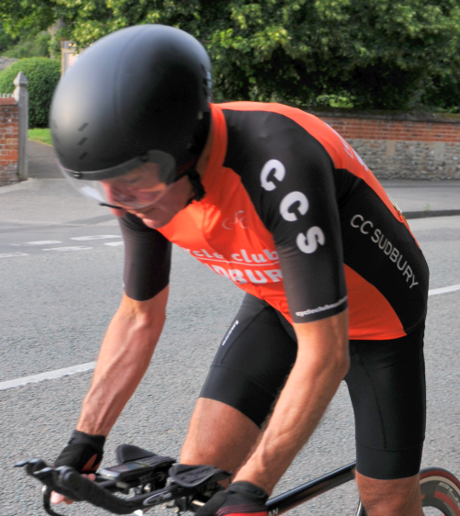
The following day in fine weather we met in Long Melford we headed out to Stansted, Glemsford, down Brook Street, straight on at the bottom of Fern Hill and up Scotts Hill on the road to Stansfield. Heading right up Plough Hill out of Stansfield on to Hawkedon, left in Hawkedon to pass the Queens Head Pub (closed) then a long climb past the Hawkedon Veterinary to turn right into Cooks Lane to Brockley and left to Hartest to take in Hartest Hill. After a short break at the top of Hartest Hill I decided to take in the pleasures of riding up the Hartest Hill for a second time. We took a short diversion to Shimpling as far as Chad Brook then return up the hill and on to Stanstead and a second climb of Glemsford Hill to the Church. At this point we decided to take in some of the hills around Pentlow, Cavendish and return to Glemsford for a repeat of the Hawkedon circuit. Unfortunately, my endorsement of Marathon Plus tyres and their resistance to punctures came back to haunt me at the top of Scotts Hill on the second circuit. Naturally Colin took great pleasure in reminding me of my words of the previous day whilst I got on with changing the inner tube. I guess the moral of this story is don’t make rash statements and know when to keep your mouth shut. Anyway, we completed the second circuit with another climb of Hartest Hill, at this point we were only a few feet short of our 2500 feet target so Colin rode home via Bridge Street to Lavenham whilst I continued on to Stanstead, Long Melford and home to record 55 miles with 2723 feet of climbing to finally complete the CW5000 February challenge.
Total mileage for February 736 miles.

Brian Mann’s Wacky Photo’s taken from the Saddle
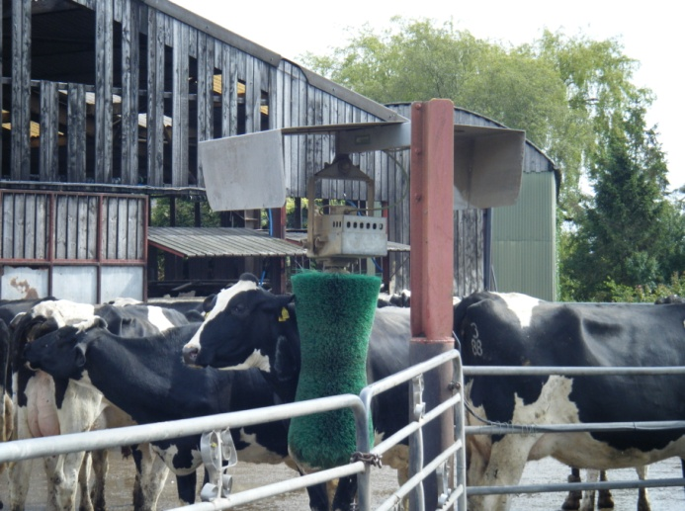
Roger, I spotted these while taking part in the CTC British
Cycle Quest’s.....................................................
The cows waited patiently for their turn to use the revolving back scratcher and I spent ages watching them.
The rear end of the motorbike became a house sign in Sussex.
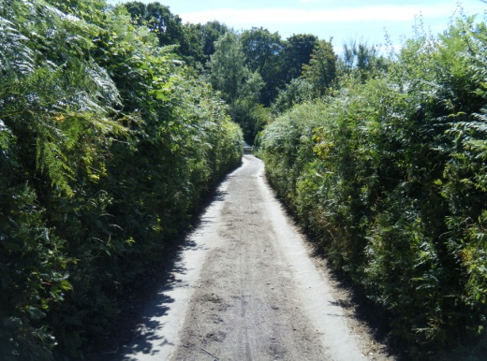
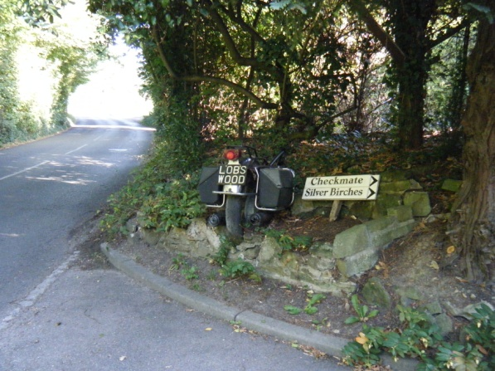
The narrow road pictured was in Somerset and was too narrow even for cars, the owner of the one pictured would go no further!
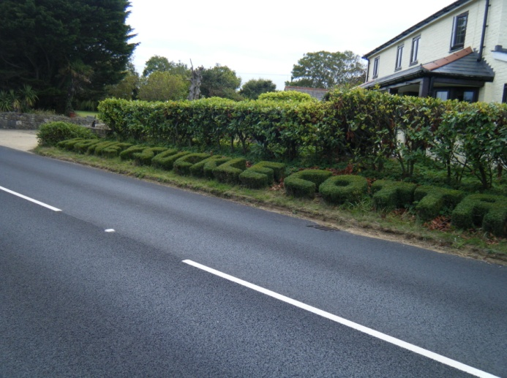
I saw the Honeysuckle Cottage topiary while Questing on the Isle of Wight, 155km of hilly riding which started at 4am in Winchester and included a road closure and diversion in the dark which meant I missed my ferry by no more than a minute and had to wait an hour for the next one, and finished with a frantic dash from Cowes to East Cowes via the floating bridge which connects the two towns to catch my return boat to make sure I avoided rush hour Southampton and Eastleigh, a satisfying day though despite the dramas as I completed 6 quests on the island and bagged a seventh on my return to Winchester.
The farm gate signs spotted in Cheshire and were to the point!
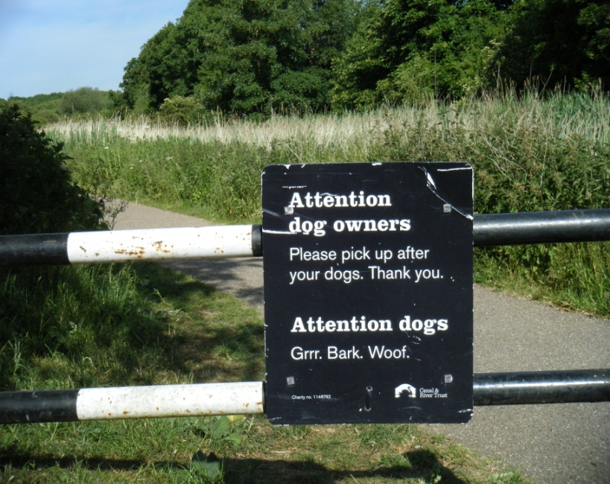
Hope this helps to fill space, Brian
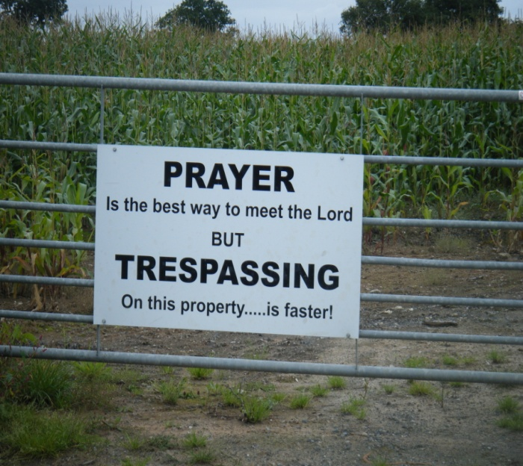
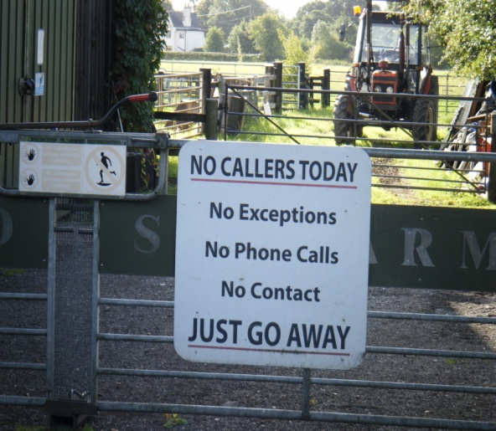
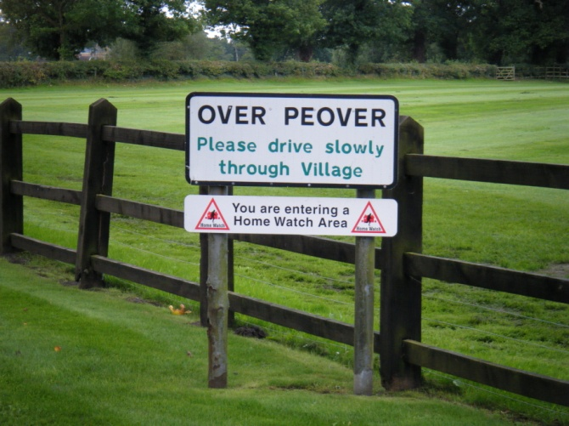
Good pics Brian
More please!

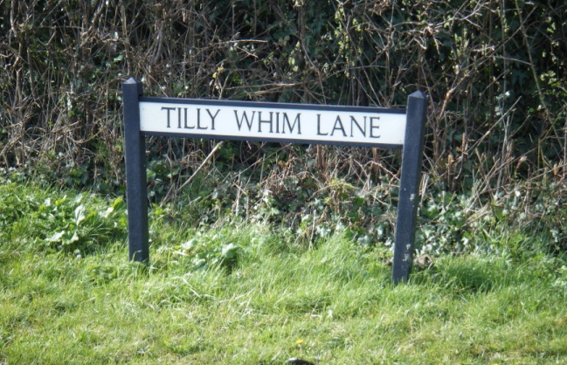
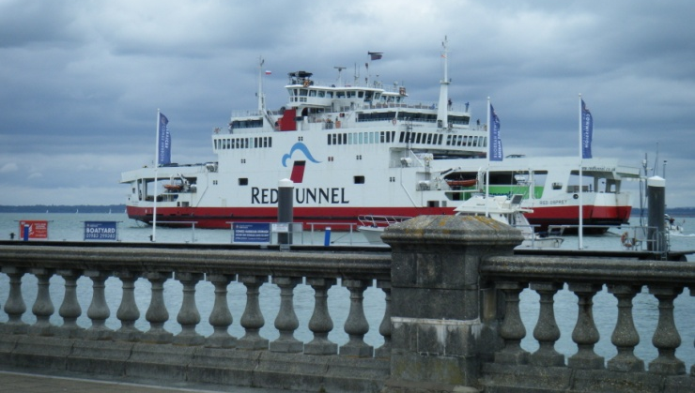

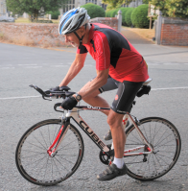
An Alternative to Cycling .....by David Miller

About 3 years ago I joined Hadleigh Hares Athletic Club (HH) to try and increase my cardio vascular fitness during winter months (I can’t stand sitting on a turbo trainer pedalling away)
HH run two training sessions each week for approx. 1 hour on a Monday and Thursday evening through the year, each session is run by either 2 or 3 trainers (club members who have attended the England Athletics Training courses) the training sessions are, beginners which encompass couch to 5k, improvers and experienced runners.
Training sessions are geared to the particular group but always comprise a long warm up session followed by, either, Hill Repeats or similar, Fartlek training (fast running with periods of slower running) long runs out, or in the summer months field work sessions.
Depending on the number of runners or trainers sometimes the groups are combined.
On the longer runs the trainer will set way points so the faster runners can hare off, but when they reach the way point will run back to the slower runners and re-join at the rear of the group which will always have the trainer present, that way nobody gets left alone or isolated and in fact some of the stronger runners provide support and encouragement to novice and less able runners.
All winter training sessions runners must have head or body lights and hi-viz clothing especially as some sessions are on unlit roads
During summer months as an alternative to the Thursday night session the club hires the running track at Northgate School and afterwards meet in the local pub and provide free of charge bar snacks for those who attended,
Now whilst running is not everybody’s idea of fun I find especially during winter months a run of 5k can be undertaken in rain or cold 30-35mins without too much stress. My cycling colleagues have said you should not be running at your age you will get bad knees and joints but so far I have been ok apart from injuries sustained other than running and in one case pulled a back muscle getting my winter bike down off the high rack in the garage.
Happy exercise which ever you choose
2 Good Spec’ Road Bikes for Sale (Both in excellent condition)
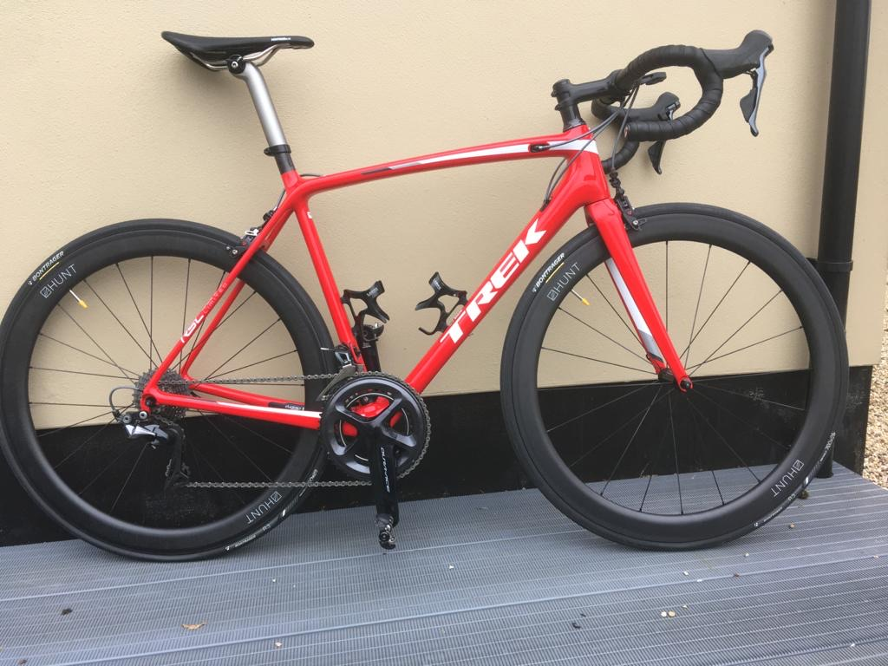
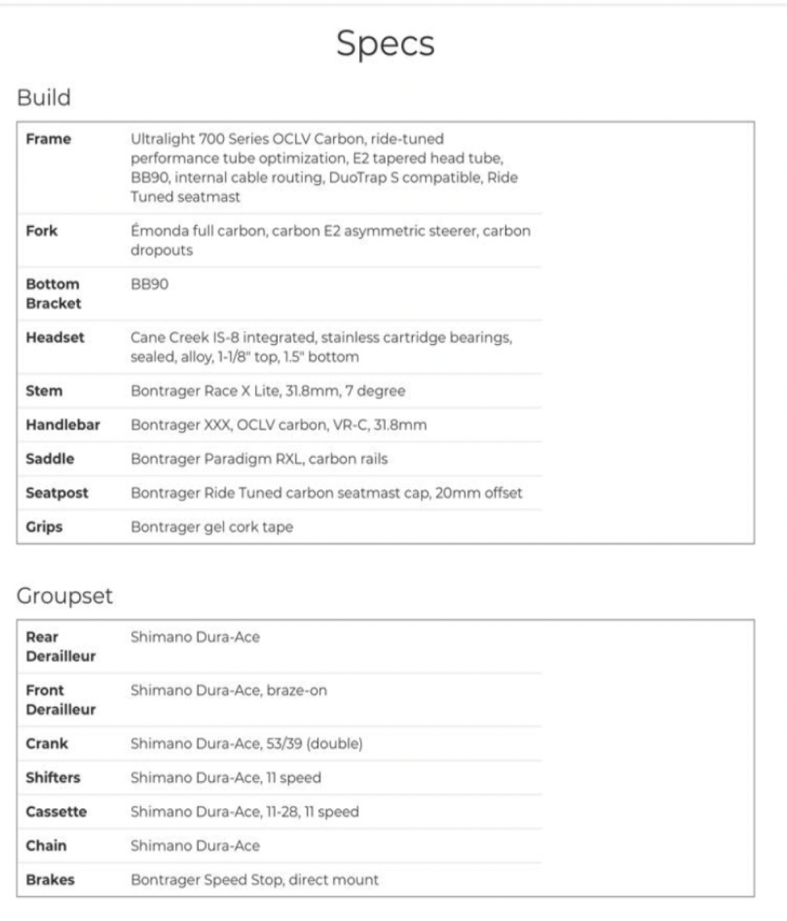
Additional Hunt Carbon Wheels Included
£3,995.00 ONO (Less than 1,000 miles Ridden) (Contact: Daryl – 07879 943968)

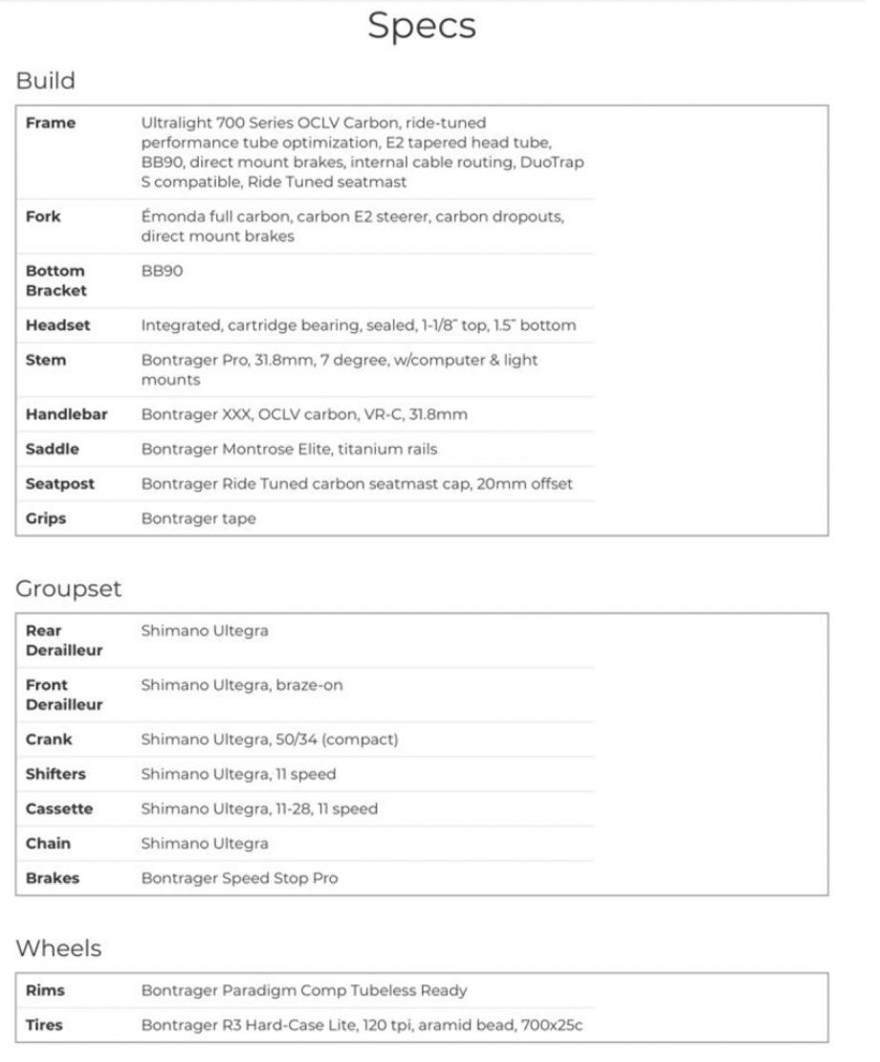

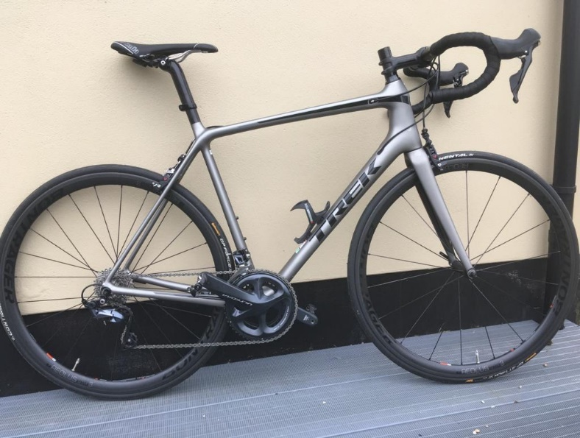
£2995-00 ONO
Less than 1000 miles ridden.
(Contact Daryl – 07879 943368)

